WSL INSTALLATION

- PowerShell opened as Administrator:
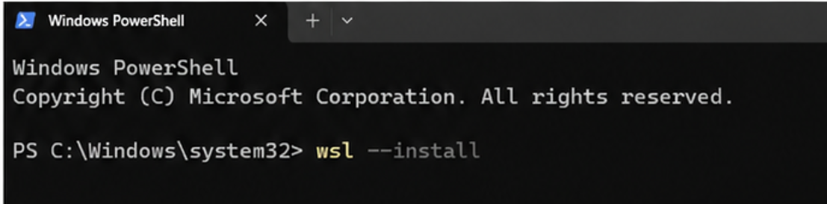

- Run:
wsl --install
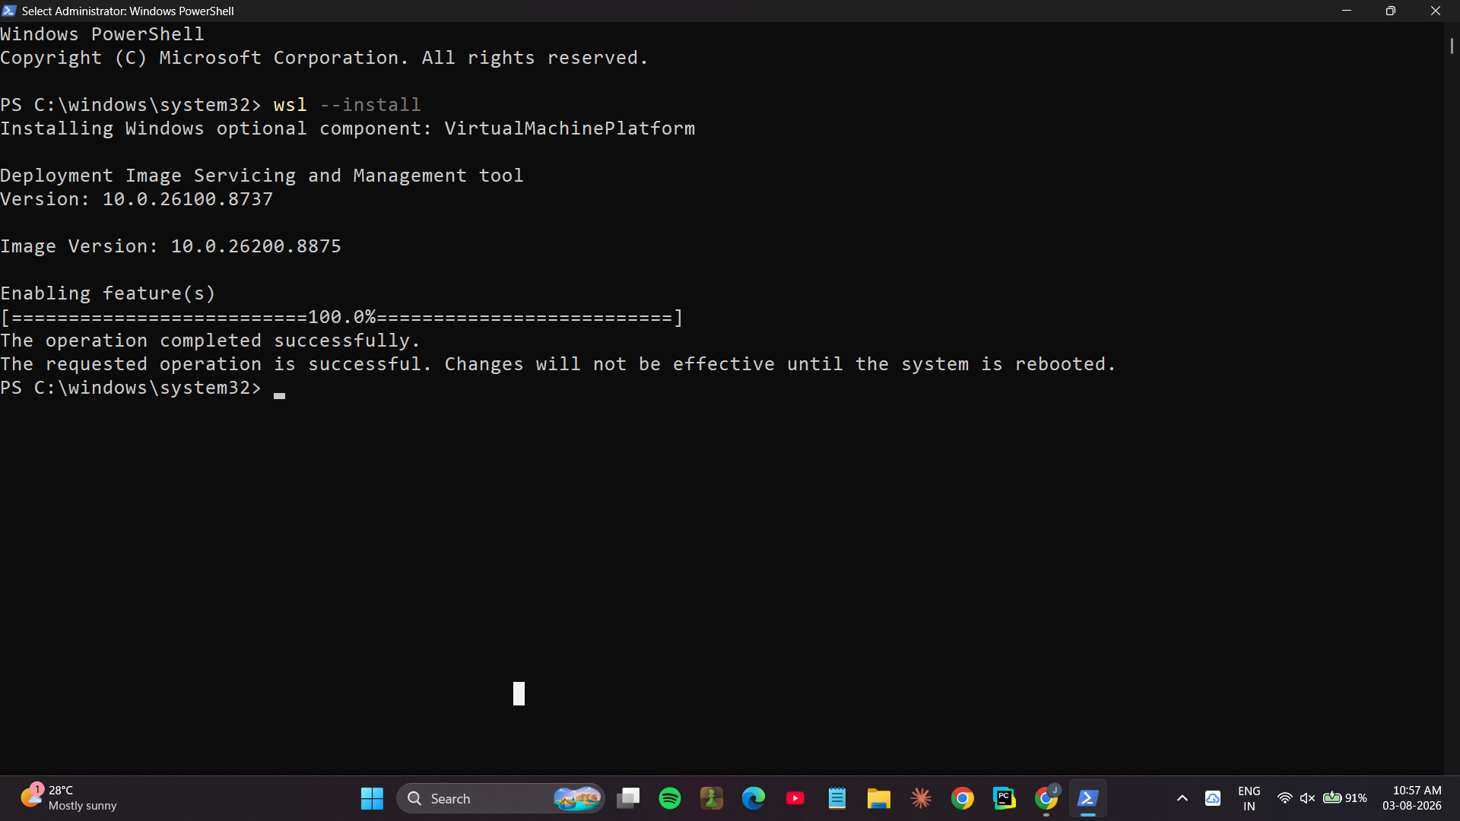

- Restart Your Computer
After installation, restart your PC when prompted.
- Complete Ubuntu Setup
After restarting:
=>Ubuntu opens automatically (or search for Ubuntu in the Start menu).
=>Wait for the installation to finish.
=>Create a Linux username.

Example:
Enter new UNIX username: anusha
- Create a Password
You'll then be prompted to create a password.
New password: ****
Retype new password:****
- Update Ubuntu
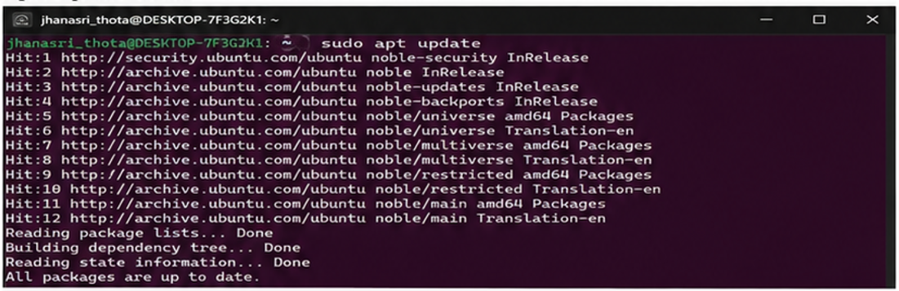

- Install GCC (C Compiler)

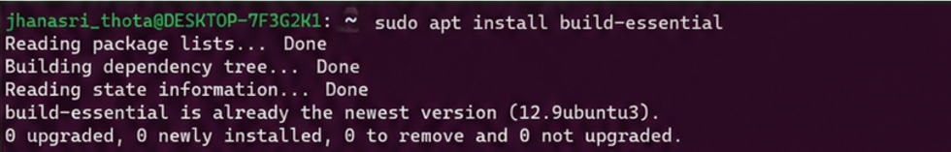

- Verify the Installation
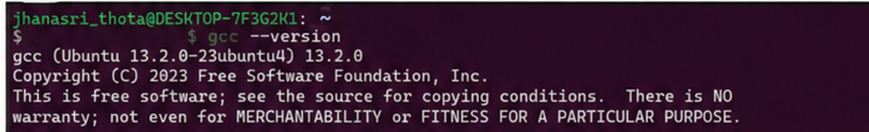
- Create Your C Program - ex:nano process.cc
- Compile the Program

